Toolbars
The program will have a set of built in toolbars that the user may hide or display. The program will keep track of the positions and sizes of active toolbars so that the settings can be restored each time the program is executed. All toolbars will be dockable.

Standard Toolbar
The standard toolbar is shown in Figure 1. This toolbar contains buttons for the standard commands.
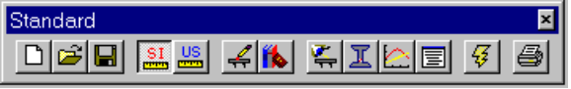
Figure 1 Standard Toolbar
Button | Corresponding Command
 | File | New
 | File | Open
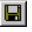 | File | Save
 | Project | Units. SI Units in the Units Dialog
 | Project | Units. US Units in the Units Dialog
 | Project | Edit Bridge
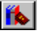 | Library | Edit Libraries
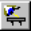 | View | Bridge Model
 | View | Girder Model
 | View | Analysis Results
 | View | Report
 | Project | Update Now
 | File | Print
Table 1 Standard Toolbar Buttons

Library Toolbar
The library toolbar is shown in Figure 2. This toolbar contains buttons for the library editing commands.
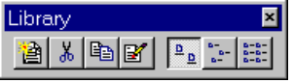
Figure 2 Library Toolbar
Button | Corresponding Command
 | Library | Add New Entry
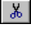 | Library | Delete Entry
 | Library | Duplicate Entry
 | Library | Edit Entry
 | Library | Large Icons
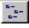 | Library | Small Icons
 | Library | List
Table 2 Library Toolbar Buttons

Help Toolbar
The help toolbar is shown in Figure 3. This toolbar contains buttons for the help commands.
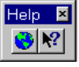
Figure 3 Help Toolbar

Button | Corresponding Command
 | Help | Online Resources | PGSuper Home Page
 | No corresponding menu item. This is the context help tool.
Table 3 Help Toolbar Buttons

